**Seychelles country profile**

Published

14 May 2018

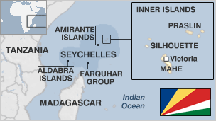

**After an ominous, post-independence start which included a coup, an invasion by mercenaries, an abortive army mutiny and several coup attempts, the Seychelles have attained stability and prosperity.**

Today the Indian Ocean archipelago enjoys a high per capita income, good health care and education.

The former British colony's economy depends heavily on the fishing industry and upmarket tourism.

It features in the 2017 leak dubbed the Paradise Papers, which reveal the financial dealings of politicians, celebrities, corporate giants and business leaders.

Seychelles also is home to an array of wildlife, including giant tortoises and sea turtles. Much of the land is protected as part of nature reserves.

* Read more [country profiles](http://news.bbc.co.uk/1/hi/country_profiles/) - Profiles by [BBC Monitoring](http://bbc.co.uk/monitoring)

**President: Danny Faure**

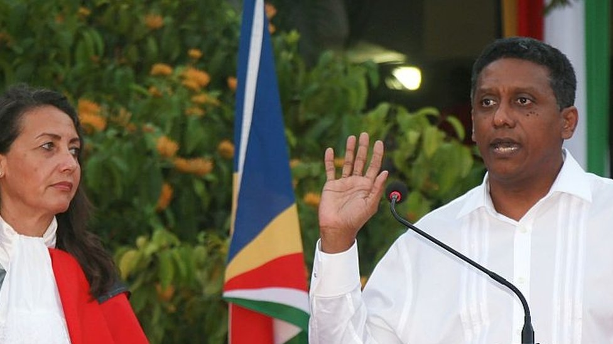image copyrightGetty Images

Danny Faure was sworn in as president in October 2016 and is to complete the five-year term of outgoing President James Michel, who resigned.

Mr Michel gave no reason for his resignation, but it followed parliamentary elections where the opposition coalition Linyon Demokratik (LDS) took control of the legislature from the ruling People's Progressive Front, called Parti Lepep, for the first time in the country's history.

Mr Faure was previously vice president. He is a former finance minister, a governor of the International Monetary Fund (IMF), the World Bank and the African Development Bank.

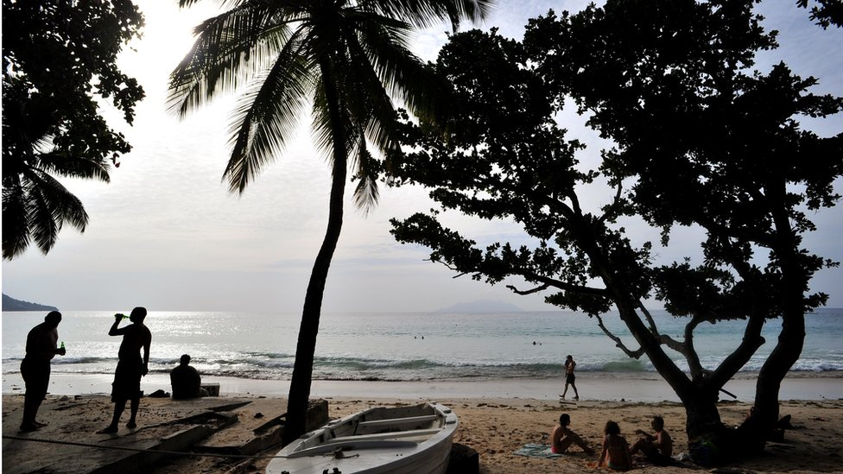image copyrightGetty Images

image captionSeychelles is a favoured destination among holiday makers seeking sunshine and beaches

The government controls much of the islands' media, and operates radio and TV stations and the sole daily newspaper.

Private or pro-opposition publications can be robust in their reporting despite tough libel laws.

# Seychelles profile - Timeline

Published

14 May 2018

**A chronology of key events:**

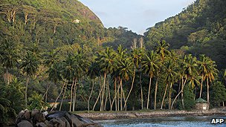image copyrightAFP

image captionThe islands are a year-round tourist destination

**1502** - Portugal's Vasco da Gama explores the Seychelles.

**1768** - French planters and their slaves begin settling in the Seychelles.

## British rule

**1794** - Britain annexes the Seychelles, which are then administered from Mauritius.

**1903** - Seychelles become a separate British colony.

**1948** - First elections to a legislative council take place.

**1964** - First political parties are formed: France Albert Rene's socialist Seychelles People's United Party and James Mancham's pro-business Seychelles Democratic Party.

**1966, 1970** - The Seychelles Democratic Party wins legislative elections.

## Independence

**1976** - Seychelles become independent and are governed by a coalition, with James Mancham as president and France Rene as prime minister.

**1977** - Rene's supporters stage a coup against Mancham ostensibly without Rene's knowledge; Rene installed as president.

## Political changes

**1978** - Rene enacts a new constitution, turning the Seychelles into a one-party state.

**1981** - South African-based mercenaries try but fail to restore Mancham to power.

**1982** - Army mutiny thwarted.

**1991** - President Rene restores multiparty democracy.

**1993, 1998** - Rene re-elected in multiparty ballots.

**1998** - Rene's Seychelles Progressive People's Front wins 30 out of 34 seats in parliamentary elections.

## Rene re-elected

**2001** September - President Rene wins another term in office with 54% of the votes, beating opposition candidate Wavel Ramkalawan who won 45% of the votes.

**2002** December - President Rene's Seychelles Progressive People's Front wins parliamentary elections, but the opposition Seychelles National Party increases its presence from one to 11 seats.

**2003** July - Economic reforms are introduced under which Seychelles will pull out of the Southern African Development Community (SADC) and close three diplomatic missions.

**2004** April - President Rene steps down, replaced by former vice president James Michel.

**2004** December - Widespread damage is reported after giant waves, generated by an underwater earthquake off Indonesia, hit three islands.

**2006** July - President Michel wins presidential race.

**2006** October - Parliament bans political or religious organisations from running radio stations, sparking a rare outbreak of unrest.

**2007** May - The ruling SPPF wins early elections. They were brought forward after opposition MPs boycotted parliament over moves to ban political parties from owning radio stations.

**2008** November - International Monetary Fund agrees a two-year $26-million rescue package for the indebted Seychelles economy.

**2009** January - President Michel asks creditors to cancel half the archipelago's $800 million foreign debt. The economy has been hit by reduced tourist traffic and turmoil in the world's financial markets.

**2009** April - Somali pirates move their operations southwards to Seychelles and beyond as patrols are stepped up in the Gulf of Aden.

**2009** October - US says it will supply Seychelles with drone spy-planes to help fight piracy. France offers legal help.

**2009** November - Seychelles, European Union sign anti-piracy agreement which will allow EU troops to be deployed on the islands.

World Bank approves $9 million loan to help indebted Seychelles to restore economic stability.

**2010** July - First successful prosecution of pirates in Seychelles. Eleven Somalis are jailed.

**2010** August - Seychelles signs up to International Criminal Court.

**2011** May - President Michel re-elected.

**2012** April - A US drone crash lands after take-off from the islands, which are reportedly being used as a base for flights monitoring pirates and Somalia.

**2013** April - Sakher El Materi, the son-in-law of ousted Tunisian president Zine al-Abidine Ben Ali, is granted asylum in the Seychelles. The move prompts a diplomatic tussle with Tunisia, which seeks his extradition.

**2013** April - Seychelles signs a tax exchange agreement with The Isle of Man, as part of moves to develop closer economic and taxation co-operation.

**2015** December - President James Michel wins a third term by the narrowest of margins, beating Seychelles National Party leader Wavel Ramkalawan.

**2016** May - Seychelles becomes one of a minority of African countries to decriminalise gay sex.

**2016** September - Opposition LDS wins parliamentary elections, breaking the ruling party's four-decade grip on power.

**2017** November - The Seychelles features in the 2017 leak dubbed the Paradise Papers, which reveal the financial dealings of politicians, celebrities, corporate giants and business leaders.

**2018** February - Seychelles announces plans to create a marine reserve as part of a national debt swap deal which could serve as a model for future conservation projects around the world.